**International Institute of Professional Studies**

**Devi Ahilya Vishwavidyalaya Indore**



**Project Report on**

**Hospital Management System**

**Guided by:-**

Dr. Shaligram Prajapat sir

**Submitted by :-**

Nitin Dwivedi

IT-2K19-37

**BONAFIDE CERTIFICATE**

Certified that this project titled " Hospital Management System " is a bonafide work of **Nitin Dwivedi (IT-2K19-37)** who carried out the research and completed the project under my supervision. Certified further, that to the best of my knowledge, the work reported herein does not form part of any other project on the basis of which a degree or award was conferred on an earlier occasion on this or any other candidate.

Internal examiner External examiner

**ACKNOWLEDGEMENT**

It is indeed with a great pleasure and immense sense of gratitude that we acknowledge the help of these individuals. We are highly indebted to our Director **Dr. B.K.Tripathi**, International Institute of Professional Studies, for the facilities provided to accomplish this main project.

We feel elated in manifesting our sense of gratitude tour internal project guide **Dr. Shaligram Prajapat, Associate Professor,** International Institute of Professional Studies. He has been a constant source of inspiration for us and we are very deeply thankful to him for his support and valuable advice.

We express our heartful thanks to all of our friends who helped us in successful completion of this project.

**ABSTRACT**

The purpose of the project entitled as “HOSPITAL MANAGEMENT SYSTEM” is to computerize the Front Office Management of Hospital to develop software which is user friendly simple, fast, and cost – effective. It deals with the collection of patient’s information, diagnosis details, etc. Traditionally, it was done manually. The main function of the system is register and store patient details and doctor details and retrieve these details as and when required, and also to manipulate these details meaningfully System input contains patient details, diagnosis details, while system output is to get these details on to the screen. The Hospital Management System can be entered using a username and password. It is accessible either by an administrator or receptionist. Only they can add data into the database. The data can be retrieved easily. The data are well protected for personal use and makes the data processing very fast.

**4. DESIGN & PLANNING**

**4.1 Software Development Life Cycle Model**

**4.1.1 WATERFALL MODEL**

The waterfall model was selected as the SDLC model due to the following reasons:

* Requirements were very well documented, clear and fixed.
* Technology was adequately understood.
* Simple and easy to understand and use.
* There were no ambiguous requirements.
* Easy to manage due to the rigidity of the model. Each phase has specific deliverables and a review process.
* Clearly defined stages.
* Well understood milestones. Easy to arrange tasks.

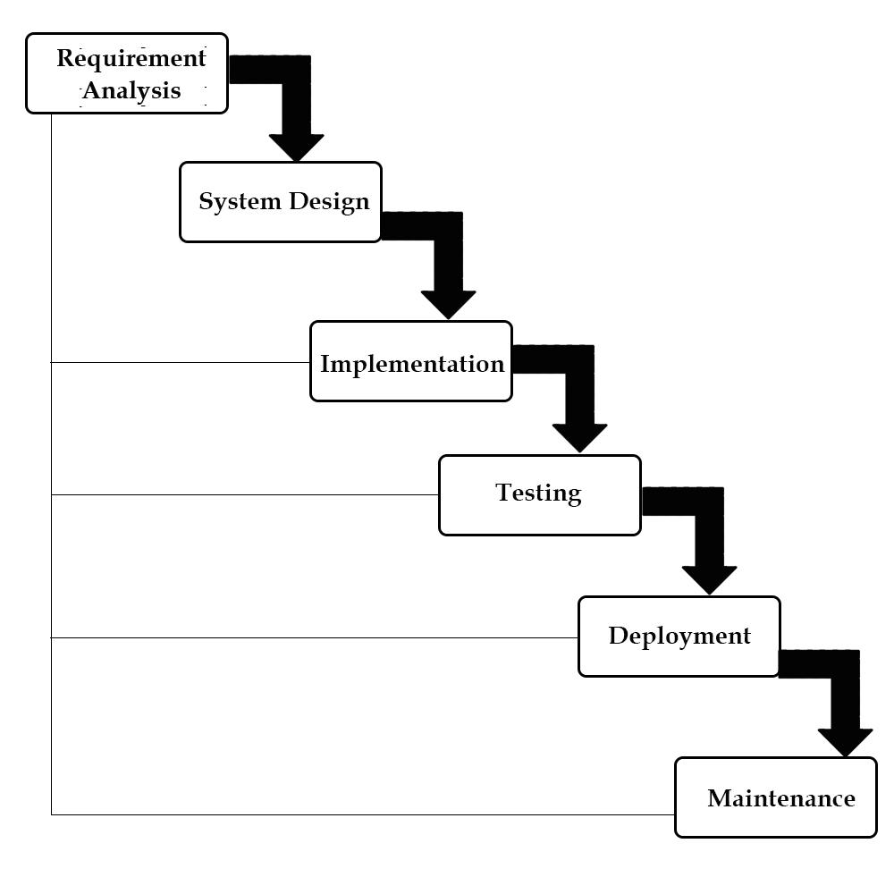

**4.2 Use case diagram:**

A use case diagram in the Unified Modelling Language(UML) is a type of behavioural diagram defined by and created from a use-case analysis. Its purpose is to present a graphical overview of the functionality provided by a system in terms of actors, their goals(represented as use cases),and any dependencies between those use cases.

Use case diagrams are formally included in two modelling languages defined by the OMG:theunfied modeling language(UML) and the systems modelling language(sysML)

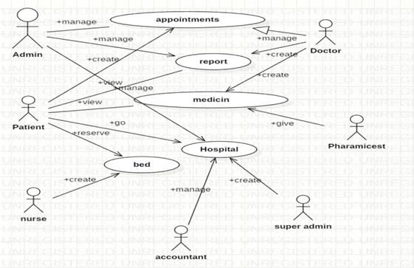

**4.3 Class Diagram:**

A Class is a category or group of things that has similar attributes and common behaviour. A Rectangle is the icon that represents the class it is divided into three areas. The upper most area contains the name, the middle; area contains the attributes and the lowest areas show the operations. Class diagrams provides the representation that developers work from. Class diagrams help on the analysis side, too.

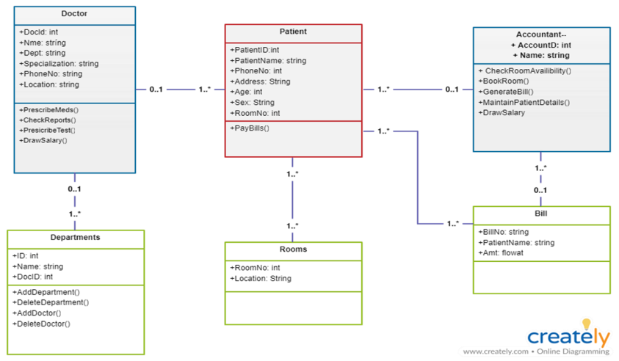

**4.4 Sequence diagram:**

A **Sequence Diagram** is an interaction diagram that emphasis the time ordering of messages; a collaboration diagram is an interaction diagram that emphasizes the structural organization of the objects that send and receive messages. Sequence diagrams and collaboration diagrams are isomorphic, meaning that you can take one and transform it into the other.

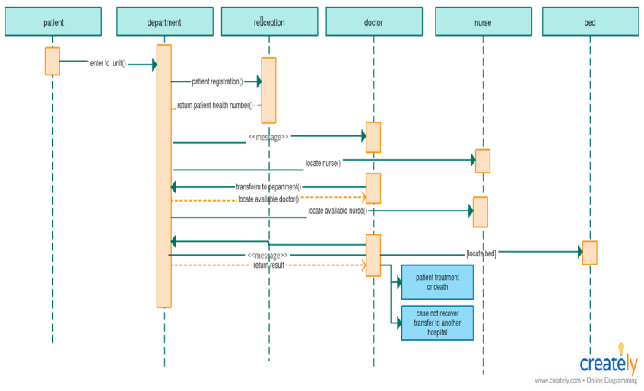

**4.5 Activity diagram:**

An **Activity diagram** is another important behavioural diagram in [UML](https://en.wikipedia.org/wiki/Unified_Modeling_Language) diagram to describe dynamic aspects of the system. Activity diagram is essentially an advanced version of flow chart that modelling the flow from one activity to another activity.

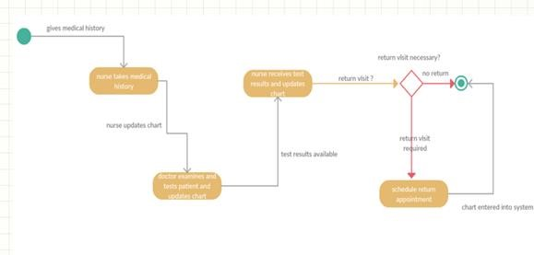

**4.6 Deployement diagram:**

A **Deployment Diagram** shows the configuration of run-time processing nodes and the components that live on them. Deployment diagrams address the static deployment view of architecture. They are related to component diagrams in that a node typically encloses one or more components.

**Hospital Local Server**

**desktop Client**

**Printer**

**Database Server**

**4.7 E-R Diagram:**

Database is absolutely an integral part of software system. To fully utilize ER Diagram in database engineering guarantee you to produce high quality database design to use in database creation, management and maintenance. An ER model also provides a means for communication.

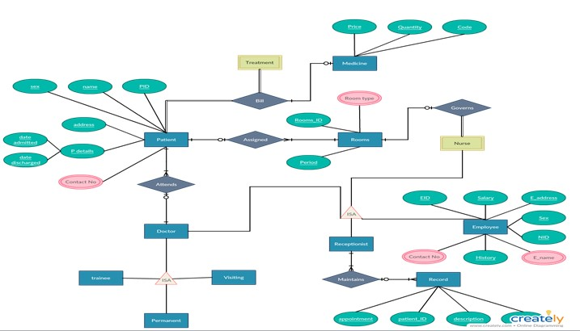

**4.8 Data Flow Diagram:**

**4.8.1 0 Level DFD**

Hospital Management System



4. Data Flow Diagrams




        DFD: Level 0




            16
 

**4.8.2 1st Level DFD**

Hospital Management System




      DFD: Level 1




           17
 

**4.8.3 2nd Level DFD**

Hospital Management System




       DFD: Level 2




           18
 

**4.8.4 3rd Level DFD**

Hospital Management System




       DFD: Level 3




           19
 